Επεξηγήσεις:
- photograph, usually on film, with normal polarity that is created during a two-step process to duplicate negatives
Notes: Interpositives are typically made using negative film; a negative of a negative produces a positive image. The interpositive is then used to make another negative. Interpositives are frequently used to make printing masters from original camera film or to reproduce still negatives that are deteriorating. Interpositives can be either color or monochrome. {2}
- A negative, made from a transparency, which is used to make prints or copies.
Notes: Internegative is sometimes used to describe copy negatives made from prints. {2}
- Technocran: a telescopic crane designed and built to offer limitless creative possibilities in the camera movement. {5}
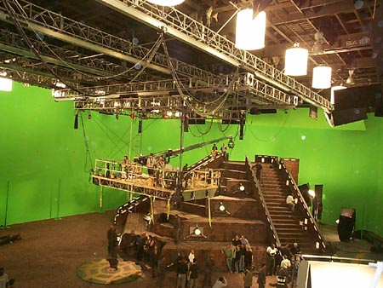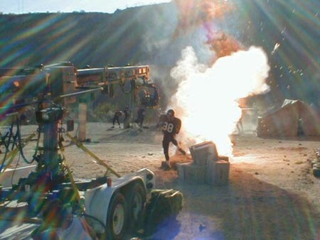

- Cel animation: Traditionally known animation created by drawing out frames for a flipbook, then once the frames are previewed and approved, they are inked and painted onto "cels" which are celluloid plastic sheets that are clear. These can be combined with other cels and a background to complete the shot. The cels are then played back, usually at 24 Frames Per Second, to give the illusion of movement. Although a very labor intensive process, the end result of cel animation is distinctively different, creative and appealing. {6}

Αρθρογραφία

(1) Lev Manovich, What is digital cinema, The Language of New Media, MIT Press, Cambridge, MA, 2001.
(2) Birger Sevaldson, Computer Aided Design Techniques, Designer Member of OCEAN north Associate Professor Oslo School of Architecture
(3) Stephen Prince, The Emergence of Filmic Artifacts – Cinema and Cinematography in the Digital Era

Βιβλιογραφία

[1] Pamela Howard, Τι είναι σκηνογραφία, μετάφραση: Ευαγγελία Κινρίκε, (Επίκεντρο, 2002).
[2] Marcel Martin, “Η γλώσσα του κινηματογράφου”, μετάφραση: Ευγενία Χατζίκου, (Κάλβος, 1984).
[3] Dan Ablan, Digital Cinematography & Directing, 1st ed. (New Riders Press, 2002).
[4] Ken Dancyger, Technique of Film and Video Editing, Second Edition: Theory and Practice, 2nd ed. (Focal Press, 1996).
[5] Rob Napoli and Chuck Gloman, Scenic Design and Lighting Techniques: A Basic Guide for Theatre (Focal Press, 2006).
[6] Renato Lori, Le métier de scénographe : Au cinéma, au théâtre et à la télévision (Gremese, 2006).
[7] Matt Hanson, Matt. Building Sci-Fi Moviescapes: The Science Behind the Fiction. Focal Press, 2005. Print.
[8] Charles S. Swartz, Understanding Digital Cinema: A Professional Handbook, 1st ed. (Focal Press, 2004).
[9] Paul Wheeler, Digital Cinematography (Focal Press, 2001).
[10] Γιάννης Βασιλειάδης, Animation Ιστορία και αισθητική του κινουμένου σχεδίου, 1st ed. (Αιγόκερως, 2006).
[11] Thomas G. Smith, Industrial Light & Magic: The Art of Special Effects, 1st ed. (Del Rey, 1987).
[12] Raymond Fielding, Techniques of Special Effects of Cinematography, 4th ed. (Focal Press, 1985).
[13]David Bordwell, Kristin Thomson, Εισαγωγή ση τέχνη του κινηματογράφου, 5th ed. (the McGraw – Hill Companies, 1997), μετάφραση: Κατερίνα Κοκκινίδη
[14] Νίκος Καβαγιάς, Ο κινηματογράφος χωρίς μυστικά και η τέχνη του οπερατέρ, (εκδόσεις Καστανιώτη, 2005)
[15] Ben Long/ Sonja Schenk, the Digital Filmmaking handbook, 3rd ed. (Thomson Delmar Learning, 2006)

Websites
{1} http://scratch.mit.edu/
{2} http://www.archivists.org/
{3} http://www.areteimagesoftware.visualnet.com/
{4} https://renderman.pixar.com/
{5} http://www.technocrane.net/mainmenu.html
{6} http://www.mediapostinc.com/animation.cfm?wid=27
{7} http://www.wired.com/magazine/2010/05/process_pixar/all/1 (“wired” e - magazine)
{8} http://www.nvidia.com/object/feature_pixelshader.html
{9} http://www.nvidia.com/object/feature_pixelshader.html
{10} http://www.theasc.com/ac_magazine/April2010/PresidentsDesk/page1.php (Michael Goi, ASC President American cinematographer, magazine’s digital edition, April 2010)
{11} http://www.theasc.com/ac_magazine/April2010/AliceinWonderland/page1.php

